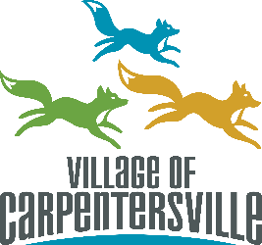
SPECIAL EVENTS ADVISORY COMMITTEE
VILLAGE HALL
1200 L.W BESINGER DR
CARPENTERSVILLE, IL 60110

AGENDA
Regular Meeting 6:00 pm February 10, 2026

I. Call to Order
II. Roll Call
Jo Maniscalco ___ Yuli Pandocchi ___ Evelyn Guerrero ___ Nicole Bertrand ___ Nelly Garcia ___
III. Approval of Minutes
- January 22, 2026
IV. Public Comment
(Limited to five (5) minutes total unless otherwise directed by the Chair)
V. Presentations
VI. Budget
VII. Old Business
VIII. New Business / Items for Discussion
A. St. Patrick’s Day Parade Float
- Overview and committee input
B. Jamboree Days
- Event scope and vision
- Key planning focus areas:
  - Marketing & promotion
  - Sponsorship opportunities
  - Volunteer engagement
C. Independence Day Parade (2026 – 250th Celebration)
- Early planning overview
- Parade participant outreach update
- Committee input and ideas
IX. Staff Liaison Report
X. Adjournment

